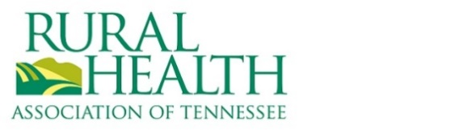

Board Application Form

Please complete the below form and return to info@tnruralhealth.org RHA of TN’s Nominating will review and recommend a slate of candidates to the Board of Directors. Applications for candidates approved to the ballot will be shared with membership prior to voting.

Name:
Employment:
Title:

- What about RHA of TN’s Mission to “Lead the way for a healthy tomorrow throughout rural Tennessee” excites you?

- How have you engaged with the organization over the last 1-2 years? (committees, conference, etc)

- Who in your network can you involve in the organization?

- What personal qualities can you bring to the board?

- Can you commit to a 3-year term and attending 4 board meetings annually, the annual conference, and serving on at least 1 committee yearly?

